AI-Powered Traffic Management System: Use computer vision & AI to detect traffic violations

CONTENT | PAGE NO
Abstract
1.INTRODUCTION
1.1 Motivation
1.2 Problem Statement
1.3 Objective of the Project
1.4 Scope
1.5 Project Introduction
2.LITERATURE SURVEY
2.1 Related Work
3. SYSTEM ANALYSIS
3.1 Existing System
3.2 Disadvantages
3.3 Proposed System
3.4 Advantages
4. REQUIREMENT ANALYSIS
4.1 Function and non-functional requirements
4.2 Hardware Requirements
4.3 Software Requirements
4.4 Architecture
5. SYSTEM DESIGN
5.1 Introduction of Input design
5.2 UML Diagram(class, use case, sequence, collaborative, deployment, activity, ER diagram and Component diagram)
6. IMPLEMENTATION AND RESULTS
6.1 Modules
6.2 System
6.3 Algorithms (YOLOv8)
6.4 Output Screens
- SYSTEM STUDY AND TESTING
7.1 Feasibility study
8. CONCLUSION
9. FUTURE ENHANCEMENT
REFERENCES

ABSTRACT
This project proposes a deep learning-based system to detect traffic violations, including not wearing a helmet, triple riding, phone usage while riding, and wheeling, using YOLOv8 and YOLOv11 (You Only Look Once versions 8 and 11). The system leverages the advanced object detection capabilities of both YOLOv8 and YOLOv11 to identify and classify these violations in real-time from video feeds, ensuring enhanced road safety. The application aims to improve traffic law enforcement by automatically detecting dangerous behaviors, providing a reliable solution for monitoring and preventing accidents.
Keywords: YOLOv8, YOLOv11, helmet violation, triple riding, phone usage detection, wheeling, deep learning, object detection, traffic safety, real-time monitoring.

.INTRODUCTION

1.INTRODUCTION

1.1 Motivation
Ensuring the safety of riders by detecting violations such as not wearing helmets, triple riding, using a phone while riding, and performing wheelies is vital for road safety. Traditional traffic law enforcement methods rely heavily on human observation, which is slow, error-prone, and inefficient. The motivation behind this project is to leverage the power of deep learning models like YOLOv8 and YOLOv11 to automate the detection of these dangerous traffic violations. The goal is to improve road safety by reducing accidents and enhancing the efficiency of traffic enforcement using state-of-the-art object detection algorithms.

1.2 Problem Statement
Manual monitoring of traffic violations is a labor-intensive process with inconsistent results and limited scalability. With the increasing number of vehicles on the road, traditional methods struggle to effectively detect multiple violations simultaneously. This project aims to address these limitations by utilizing the advanced capabilities of YOLOv8 and YOLOv11 models for object detection. These models will enable automated, real-time detection of violations such as not wearing a helmet, triple riding, and distracted driving, offering an accurate, scalable, and efficient solution for traffic law enforcement.

1.3 Objective of the Project
The primary goal of this project is to develop an automated system for detecting traffic violations through advanced deep learning models, specifically YOLOv8 and YOLOv11. This system will be capable of detecting and classifying a range of traffic violations, including not wearing helmets, triple riding, phone usage while riding, and wheeling. The project will involve the development of a Python-based backend to process real-time video feeds, ensuring efficient detection of violations as they occur. Additionally, a user-friendly front-end interface will be designed using Streamlit, enabling traffic authorities to easily visualize the results of the detection system and interact with the data. Ultimately, the system aims to improve road safety by providing a reliable, automated solution for real-time traffic violation detection, making the process faster, more accurate, and scalable.
1.4 Scope
This project will involve:
- Collecting and preprocessing datasets containing various instances of helmet violations, triple riding, phone usage, and wheeling for training both YOLOv8 and YOLOv11.
- Training and fine-tuning these models to achieve high detection accuracy for the specified traffic violations.
- Deploying the trained models with a Python-based backend that processes video feeds in real-time.
- Building an interactive front-end with Streamlit to display real-time results of traffic violation detection.
- Evaluating the system’s performance in terms of accuracy, speed, and scalability to ensure that it can be deployed in real-world traffic monitoring environments.

1.5 Project Introduction
This project introduces a deep learning-based solution for detecting traffic violations, leveraging the powerful object detection capabilities of YOLOv8 and YOLOv11. These models can efficiently identify violations such as helmet non-compliance, triple riding, phone usage while riding, and wheeling in video footage captured by traffic cameras. The integration of a Python-based backend and a Streamlit front-end ensures seamless interaction and visualization for traffic authorities. By automating the detection process, the system aims to reduce human errors, improve enforcement efficiency, and ultimately enhance road safety.

LITERATURE SURVEY

Related Work

Year | Ref | Authors | Algorithms | Datasets | Result | Remarks
2023 | [11] | R. G. Nandhakumar et al. | YOLOv3, OCR | Self-generated | 95.5% | Focused on traffic rule violator’s number plate detection. Model unable to detect and extract fancy number plate.
2023 | [21] | S. Venkatramulu et al. | CNN | Self-generated | NA | Accuracy of the model is not clearly defined.
2023 | [14] | Q. An et al. | YOLOv5s-improved | Safety helmet wearing + SHWD dataset | 92.4% | Focused only on helmet and no helmet detection, other traffic rule violations not covered.
2022 | [16] | Tasbeeha Waris et al. | Faster R-CNN | Self-generated | 97.6% | System not trained to detect other traffic rule violations such as triple riding, wrong number plate detection.
2022 | [22] | R. S. Charran et al. | YOLOv4 + DeepSORT / Tesseract | Self-generated + Kaggle (Number Plate) | 98.0% | Multiple violation detection system developed but used separate class labels for helmet and triple riding detection.
2021 | [17] | Mallela et al. | YOLOv3, GSM | MS COCO datasets | 91.7% | System not trained to detect other traffic rule violations such as triple riding, wrong number plate detection.
2020 | [15] | H. Lin et al. | CNN based MTL | HELMET datasets | 67.3% | Frame-based motorcycle detection system achieved 95.3% accuracy in identifying motorcycles and 67.3% score in effectively counting riders and checking helmet usage.
2020 | [6] | A. Tonge et al. | CNN, mask RCNN | Self-generated | 87% | Accuracy is low, can be improved by including negative data samples.
2016 | [12] | K. Dahiya et al. | HOG, SHIFT, LBP | Self-generated | 93.8% | Implementation of preprocessing techniques makes the process slow.

3. SYSTEM ANALYSIS
3.1 Existing System
Currently, traffic violations such as not wearing helmets, triple riding, phone usage while riding, and wheeling are primarily detected using manual monitoring methods or traditional image processing techniques. These systems typically rely on human inspectors or rule-based algorithms to visually check for violations. Some advanced systems use object detection techniques like YOLOv3 or YOLOv4, but they often focus on one violation at a time, such as helmet detection, and lack the capability to detect multiple violations simultaneously. While newer systems like YOLOv8 and YOLOv11 can handle more complex tasks, many existing systems are still limited by low accuracy, inefficiency, and their inability to scale for real-time, large-scale traffic monitoring.

3.2 Disadvantages
- Limited Accuracy: Existing systems often suffer from inaccurate detection due to poor handling of complex scenarios like fancy or modified number plates, overlapping objects, and false positives.
- Lack of Scalability: Traditional monitoring systems struggle to process large-scale, real-time data from numerous cameras deployed across cities, limiting their effectiveness in dynamic traffic environments.
- Single Violation Detection: Many systems can only detect one specific traffic violation at a time, such as helmet usage, while missing out on detecting multiple violations like triple riding and phone usage simultaneously.
- Manual Monitoring: Systems that rely on human inspectors are prone to fatigue, errors, and inconsistent detection, which can lead to missed violations.
- Slow Processing: Some older systems are slow due to reliance on manual steps or traditional image processing techniques, making them unsuitable for real-time applications.
3.3 Proposed System
The proposed system employs deep learning techniques, specifically the YOLOv8 and YOLOv11 object detection models, to simultaneously detect multiple traffic violations in real-time. YOLOv8 and YOLOv11 are advanced object detection algorithms capable of handling various violations, such as:
- Helmet Violation: Detecting if a rider is wearing a helmet.
- Triple Riding: Identifying if more than two individuals are riding on a motorcycle.
- Phone Usage: Detecting if a rider is using a phone while driving.
- Wheeling: Detecting the act of lifting the front wheel of the motorcycle off the ground, which is considered a dangerous behavior.
The system processes real-time video feeds from traffic cameras and applies the YOLOv8 and YOLOv11 models trained on large datasets to identify and classify traffic violations instantly. The backend will be developed using Python, while the front-end interface will be built with Streamlit to allow traffic authorities to interact with and visualize the results seamlessly.
3.4 Advantages
- High Accuracy: YOLOv8 and YOLOv11 provide high precision and recall, ensuring accurate detection of traffic violations, even in complex or crowded scenarios.
- Real-Time Processing: The system is capable of providing real-time violation detection, enabling immediate action to be taken by traffic authorities.
- Multi-Violation Detection: Unlike traditional systems, this solution can detect multiple traffic violations (e.g., helmet use, triple riding, phone usage, and wheeling) simultaneously, providing a comprehensive monitoring solution.
- Scalable: The system can scale to accommodate large datasets and multiple cameras, making it ideal for deployment in busy urban areas with high traffic volumes.
- Reduced Human Error: Automating the detection process reduces dependence on human inspectors, thereby minimizing errors and ensuring consistent detection across all cameras.
- Cost-Effective: By automating traffic law enforcement, the system reduces the need for manual labor, which lowers operational costs and increases the efficiency of law enforcement.
- User-Friendly Interface: The front-end interface developed with Streamlit provides an intuitive and accessible platform for traffic authorities to interact with, making it easy for non-technical users to visualize and manage violation detections.

4. REQUIREMENT ANALYSIS
4.1 Functional and Non-Functional Requirements
Functional Requirements:
The primary function of the system is to detect multiple traffic violations using deep learning models like YOLOv8 and YOLOv11. These violations include helmet usage, triple riding, phone usage while riding, and wheeling. The system must be capable of processing video feeds in real-time and automatically classifying violations as they occur. This requires the ability to handle high-resolution video streams from traffic cameras, analyze the footage, and immediately alert traffic authorities when violations are detected. Another key feature is the user interface, which should be user-friendly and allow authorities to visualize results, interact with the system, and access detailed violation logs. Furthermore, the system should support data logging for the storage of violation metadata such as timestamps, locations, and the type of violation detected. The backend will need to be built with Python for real-time processing, while the front-end interface will be implemented using Streamlit.
Non-functional Requirements:
The system should meet several non-functional requirements to ensure its performance, scalability, and reliability. Accuracy is critical, with the system needing to detect violations with minimal false positives and false negatives. The system should also offer real-time processing, ensuring that detection and alerts are provided without delay. To accommodate large-scale monitoring, the system must be scalable, able to handle multiple video streams from numerous cameras across a city or region. The system’s performance must ensure quick processing of video feeds, even in busy traffic conditions. Additionally, the system should be reliable, ensuring minimal downtime and continuous operation without interruptions. Security is also an essential requirement, as sensitive data such as violation logs and personal information must be protected from unauthorized access. The user interface should be designed with usability in mind, providing traffic authorities with an intuitive and accessible platform that requires minimal training.

4.2 Hardware Requirements
- Processor: Intel i3 or equivalent for handling basic video processing.
- RAM: 8 GB for smooth operation.
- Storage: 160 GB hard disk.
- Cameras:
  - High-definition CCTV cameras (1080p or higher resolution).
  - Frame rate: Minimum 30 frames per second (FPS).
- GPU: None specified, but NVIDIA GTX 1080 or higher is recommended for faster inference in deep learning tasks.
- Network: High-speed internet connection (minimum 1 Gbps) for smooth data transfer.
4.3 Software Requirements
- Operating System:
  - Windows 7/8/10 for the front-end development.
  - Linux-based OS (Ubuntu 18.04 or higher) for backend deployment.
- Server-side Script: HTML, CSS, Bootstrap, and JS.
- Programming Languages:
  - Python (for backend and model training).
  - JavaScript, HTML, CSS (for front-end development via Streamlit).
- Deep Learning Frameworks:
  - TensorFlow or PyTorch (for YOLOv8, v11, model implementation).
  - OpenCV (for video processing and frame extraction).
- Libraries and Tools:
  - Streamlit (for the front-end interface).
  - Flask (for API integration between backend and front-end).
  - NumPy, Pandas (for data processing and analysis).
- Database: MySQL or PostgreSQL (for storing logs and metadata of violations).
- Version Control: Git for version control and collaboration; GitHub or GitLab for repository hosting and CI/CD pipelines.
- IDE/Workbench: PyCharm or VSCode for Python development.
- Server Deployment: XAMPP Server.

4.4Architecture

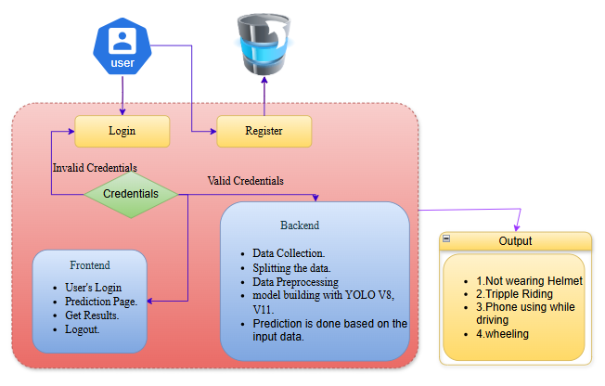

5. SYSTEM DESIGN
5.1 Introduction to Input Design
In the traffic violation detection system, input refers to the video feeds or images captured by traffic cameras, which are uploaded for processing. The system utilizes deep learning-based object detection models, specifically YOLOv8 and YOLOv11, to analyze these images or video frames and identify various traffic violations such as not wearing a helmet, triple riding, phone usage, and wheeling. A well-designed input system is essential for ensuring smooth data entry, minimizing errors, and improving the accuracy of violation detection.
Key Features of Input Design:
- Seamless Data Upload: The system allows users to upload video streams or image files through a user-friendly interface built with Streamlit.
- Preprocessing: Uploaded images or frames are preprocessed (such as resizing, normalization, and noise reduction) to enhance the performance of YOLOv8 and YOLOv11 for accurate detection.
- Validation: The system ensures proper validation of input data (e.g., checking for correct file formats like .mp4, .jpg, .png) to prevent errors and ensure high-quality inputs.
- Secure Storage: Uploaded images or video frames are stored securely for further analysis, and violation data is stored in a database for historical tracking.
Objectives of Input Design:
- User-Friendly Upload: To create a structured, simple, and intuitive system for uploading images or video feeds that can be processed by the model.
- Data Validation: To ensure that only valid image or video formats are accepted and to provide feedback on invalid data.
- Preprocessing for Accuracy: To prepare the input images or frames in a way that enhances YOLOv8 and YOLOv11’s ability to detect violations accurately.
- Secure Image Storage: To securely store input images and video data, allowing for both immediate analysis and future reference.

5.2 Output Design
Output design in this system refers to how the results of traffic violation detection are presented to users. After processing video feeds or images through YOLOv8 and YOLOv11, the system outputs visual feedback showing the detected violations. Proper output design ensures that these results are effectively communicated for quality control and enforcement purposes.
Key Features of Output Design:
- Real-Time Detection: Detected violations (e.g., helmet violations, triple riding, phone usage, and wheeling) are highlighted using bounding boxes and labels directly on the video feed or image.
- Interactive Dashboard: The results are displayed in real-time on an interactive Streamlit dashboard, providing a clear overview of detected violations.
- Violation Reports: Users can download detailed reports of detected violations, which include violation type, timestamp, and location, for further analysis or enforcement purposes.
- Historical Tracking: The system stores output data for historical tracking of violations, enabling performance evaluation and continuous improvement.
Objectives of Output Design:
- Clear Visualization: To present detected violations in an easy-to-understand format with bounding boxes and labels, ensuring that traffic authorities can quickly identify the violations.
- Real-Time Analysis: To provide real-time feedback on detected violations, allowing for immediate action by traffic authorities.
- Report Generation: To allow users to download and share detailed violation reports, which can be used for further investigation or legal purposes.
- Efficient Classification and Tracking: To ensure that violations are correctly classified, stored, and tracked over time for future analysis and reporting.

5.3 UML Diagrams
UML (Unified Modeling Language) diagrams are used to model the system’s architecture and workflow. These diagrams help in understanding system functionality and ensure efficient development and deployment.
1. Use Case Diagram:
- Represents the interactions between users (manufacturers, quality inspectors) and the system.
- Shows how users upload PCB images, view defect detection results, and generate reports.
2. Sequence Diagram:
- Defines the sequential flow of processes involved in PCB defect detection.
- Illustrates how images are uploaded, processed by YOLOv8, and results are displayed.
3. Class Diagram:
- Depicts the relationships between system components.
- Includes key entities such as the user interface, image processing module, defect classifier, and report generator.

5.2 UML Diagrams:

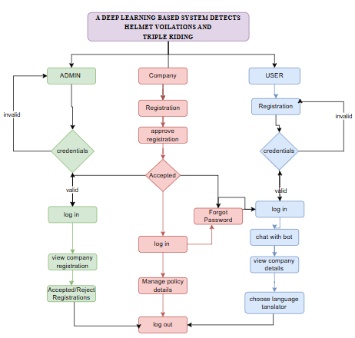
Project Flow:

UML stands for Unified Modelling Language. UML is a standardized general-purpose modelling language in the field of object-oriented software engineering. The standard is managed, and was created by, the Object Management Group.
The goal is for UML to become a common language for creating models of object-oriented computer software. In its current form UML is comprised of two major components: a Meta-model and a notation. In the future, some form of method or process may also be added to; or associated with, UML.
The Unified Modelling Language is a standard language for specifying, Visualization, Constructing and documenting the artefacts of software system, as well as for business modelling and other non-software systems.
The UML represents a collection of best engineering practices that have proven successful in the modelling of large and complex systems.
The UML is a very important part of developing objects-oriented software and the software development process. The UML uses mostly graphical notations to express the design of software projects.
GOALS:
The Primary goals in the design of the UML are as follows:
- Provide users a ready-to-use, expressive visual modelling Language so that they can develop and exchange meaningful models.
- Provide extendibility and specialization mechanisms to extend the core concepts.
- Be independent of particular programming languages and development process.
- Provide a formal basis for understanding the modelling language.
- Encourage the growth of OO tools market.
- Support higher level development concepts such as collaborations, frameworks, patterns and components.
- Integrate best practices.
USE CASE DIAGRAM
- A use case diagram in the Unified Modeling Language (UML) is a type of behavioral diagram defined by and created from a Use-case analysis.
- Its purpose is to present a graphical overview of the functionality provided by a system in terms of actors, their goals (represented as use cases), and any dependencies between those use cases.
- The main purpose of a use case diagram is to show what system functions are performed for which actor. Roles of the actors in the system can be depicted.
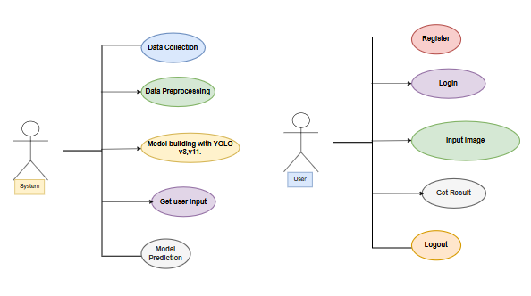
CLASS DIAGRAM
In software engineering, a class diagram in the Unified Modeling Language (UML) is a type of static structure diagram that describes the structure of a system by showing the system's classes, their attributes, operations (or methods), and the relationships among the classes. It explains which class contains information.
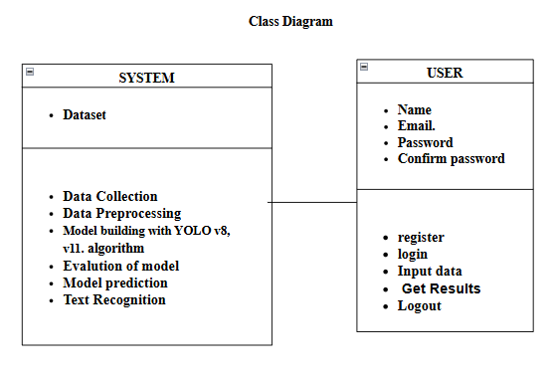

SEQUENCE DIAGRAM
- A sequence diagram in Unified Modeling Language (UML) is a kind of interaction diagram that shows how processes operate with one another and in what order.
- It is a construct of a Message Sequence Chart. Sequence diagrams are sometimes called event diagrams, event scenarios, and timing diagrams
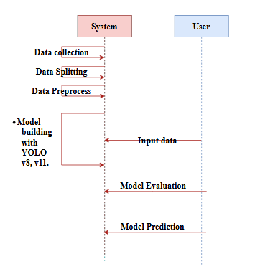
DEPLOYMENT DIAGRAM
Deployment diagram represents the deployment view of a system. It is related to the component diagram. Because the components are deployed using the deployment diagrams. A deployment diagram consists of nodes. Nodes are nothing but physical hardware’s used to deploy the application.
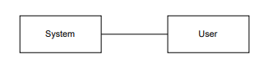
ACTIVITY DIAGRAM:
Activity diagrams are graphical representations of workflows of stepwise activities and actions with support for choice, iteration and concurrency. In the Unified Modelling Language, activity diagrams can be used to describe the business and operational step-by-step workflows of components in a system. An activity diagram shows the overall flow of control.
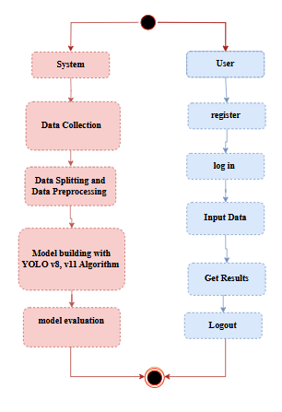

COMPONENT DIAGRAM:
A component diagram, also known as a UML component diagram, describes the organization and wiring of the physical components in a system. Component diagrams are often drawn to help model implementation details and double-check that every aspect of the system's required function is covered by planned development.
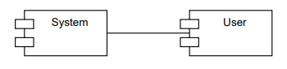
ER DIAGRAM:
An Entity–relationship model (ER model) describes the structure of a database with the help of a diagram, which is known as Entity Relationship Diagram (ER Diagram). An ER model is a design or blueprint of a database that can later be implemented as a database. The main components of E-R model are: entity set and relationship set.
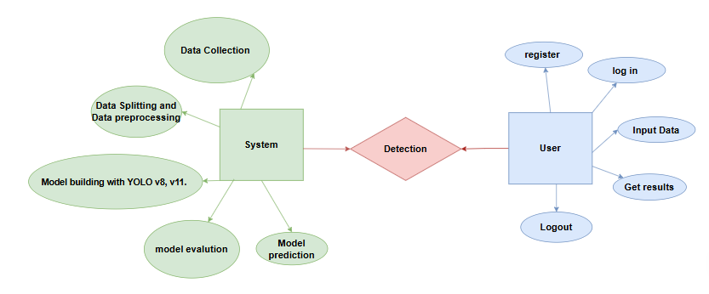
An ER diagram shows the relationship among entity sets. An entity set is a group of similar entities and these entities can have attributes. In terms of DBMS, an entity is a table or attribute of a table in database, so by showing relationship among tables and their attributes, ER diagram shows the complete logical structure of a database. Let’s have a look at a simple ER diagram to understand this concept.

DFD DIAGRAM:
A Data Flow Diagram (DFD) is a traditional way to visualize the information flows within a system. A neat and clear DFD can depict a good amount of the system requirements graphically. It can be manual, automated, or a combination of both. It shows how information enters and leaves the system, what changes the information and where information is stored. The purpose of a DFD is to show the scope and boundaries of a system as a whole. It may be used as a communications tool between a systems analyst and any person who plays a part in the system that acts as the starting point for redesigning a system.
Contrast Level:

Level 1 Diagram
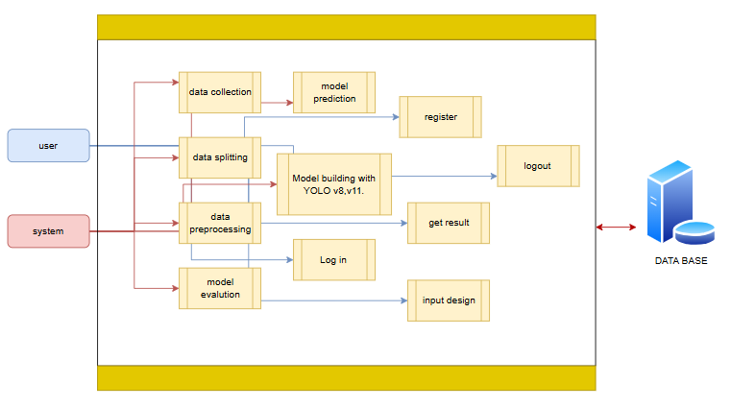

Level 2 Diagram
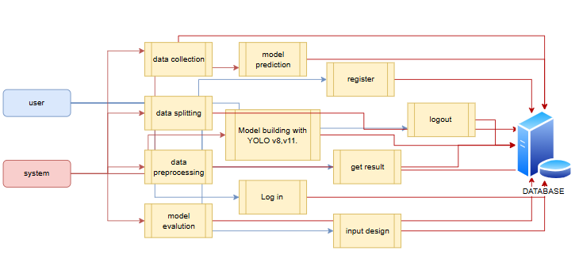

6. IMPLEMENTATION AND RESULTS

6.1 Modules

1. Users can upload a dataset, which is a crucial initial step for the system to work with relevant data. This dataset likely contains historical information or examples that the system will use for its predictions.
2. Users have the capability to view the dataset they've uploaded. This feature helps users confirm the data they've provided and ensures transparency in the process.
3. Users need to input specific values or parameters into the system to request predictions or results. These input values likely correspond to the variables or features in the dataset.

6.2 System

- Take the Dataset: The system accepts and processes the dataset provided by the user. This dataset forms the foundation for building the predictive model.
- Preprocessing: Before training a predictive model, the system preprocesses the dataset. This includes handling missing data, data cleaning, and feature extraction. Preprocessing ensures that the data is in a suitable format for modeling.
- Training: The system uses machine learning techniques and Python modules to train a model based on the preprocessed dataset. The model learns patterns and relationships within the data, allowing it to make predictions.
- Generate Results: Once the model is trained, the system can generate results based on user input values. These results typically indicate whether the input data corresponds to a specific condition, event, or prediction, such as Medical Insurance Cost

6.3 Algorithms

6.3.1 YOLO v8:

YOLO (You Only Look Once) v8 is the latest version of the YOLO family of object detection models, widely used for real-time object detection. Like its predecessors, YOLOv8 aims to balance speed and accuracy, making it ideal for applications requiring high-performance object detection. YOLO models treat object detection as a single regression problem, which makes them much faster than other approaches that involve multiple steps or region proposals.
How YOLOv8 Works
1. Input Image Processing
- The input image is resized to a fixed size, typically \(640 \times 640\) pixels, and normalized to a range of values (typically between 0 and 1).
- YOLOv8 divides the image into a grid and applies a CNN to the image, extracting features from it.
2. Backbone Network
- YOLOv8 uses a CSP-Darknet (Cross Stage Partial Darknet) as its backbone, which helps in feature extraction. This network is a convolutional neural network (CNN) that captures spatial features from the input image.
- The backbone reduces the dimensions and increases the depth of feature maps through several convolutional layers.
3. Feature Pyramid Network (FPN) and Path Aggregation Network (PAN)
- YOLOv8 incorporates FPN and PAN structures to enhance feature extraction across scales, capturing both high-level and low-level features.
- FPN extracts features at different levels, ensuring that objects of various sizes are captured effectively. PAN further aggregates these features to improve spatial understanding.
4. Head and Detection Layers
- The head is responsible for predicting bounding boxes and class probabilities.
- YOLOv8 uses multiple scales (typically 3) to predict objects, improving accuracy across small, medium, and large objects. Each scale is connected to detection layers that output bounding box coordinates, objectness score, and class probability.
5. Bounding Box Prediction
- YOLOv8 predicts bounding box coordinates using anchor boxes and regression.
- Each grid cell predicts several bounding boxes (based on anchor boxes) for each scale.
- The bounding box is parameterized by:
- \( t_x, t_y \): Offsets of the center of the bounding box relative to the grid cell.
- \( t_w, t_h \): Width and height scales relative to the anchor box.
6. Formula for Bounding Box
- If \( c_x \) and \( c_y \) are the cell center coordinates, the bounding box center coordinates \( b_x \) and \( b_y \) are:
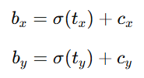
- The width \( b_w \) and height \( b_h \) are derived as:
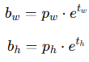
- Here, \( p_w \) and \( p_h \) are the dimensions of the anchor box, and \( \sigma \) is the sigmoid function, which keeps \( t_x \) and \( t_y \) values between 0 and 1.
7. Objectness Score and Class Prediction
- Each bounding box is assigned an objectness score that represents the probability that a detected object is present in the bounding box.
- The objectness score is computed using the logistic regression model. For each bounding box, YOLOv8 computes a class score to determine the likelihood of each class.
8. Non-Maximum Suppression (NMS)
- YOLOv8 applies Non-Maximum Suppression (NMS) to remove redundant bounding boxes for the same object.
- This is done by calculating the Intersection over Union (IoU) for pairs of bounding boxes:
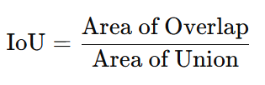
- Boxes with IoU scores above a threshold (e.g., 0.5) are suppressed, retaining only the most confident box for each detected object.
9. Loss Function
- YOLOv8 optimizes the following loss components:
- Localization Loss (IoU Loss): Measures the difference between predicted and ground truth bounding boxes.
- Confidence Loss: Measures the accuracy of the model’s objectness score.
- Classification Loss: Measures the accuracy of the predicted class label.
YOLOv8 Loss Formula
The combined loss function for YOLOv8 is as follows:
- Confidence Loss uses binary cross-entropy between predicted and true objectness scores.
- Classification Loss uses cross-entropy for multi-class classification.

6.3.2 YOLO v11
YOLOv11 (You Only Look Once version 11) is the latest evolution of the YOLO series, advancing upon its predecessors with improved accuracy and performance for real-time object detection tasks. YOLOv11 continues the trend of treating object detection as a single regression problem, which allows it to efficiently detect objects in a single pass while maintaining high speed. YOLOv11 is designed to handle complex scenarios with better precision across a wider range of object sizes and types.
How YOLOv11 Works
- Input Image Processing
  - The input image is resized to a fixed size, typically 640×640640 \times 640640×640 pixels, and normalized to a range of values between 0 and 1.
  - The image is then divided into a grid, and a convolutional neural network (CNN) is applied to extract meaningful features from each part of the image.
- Backbone Network
  - YOLOv11 uses a CSP-VGG (Cross Stage Partial Visual Geometry Group) as its backbone network for feature extraction. This backbone helps to extract both global and local features effectively, ensuring high precision and accurate representation of spatial patterns.
  - The backbone applies several layers of convolutions to reduce the dimensions of the feature maps while enhancing their depth, enabling YOLOv11 to capture intricate details of objects in the image.
- Feature Pyramid Network (FPN) and Path Aggregation Network (PAN)
  - YOLOv11 incorporates the Feature Pyramid Network (FPN) and Path Aggregation Network (PAN) to improve feature extraction across multiple scales.
  - FPN ensures that both high-level and low-level features are captured effectively at different scales, which is important for detecting objects of varying sizes.
  - PAN aggregates these features for better spatial representation and improves the overall understanding of object locations, especially in cluttered environments.
- Head and Detection Layers
  - The head of YOLOv11 is responsible for predicting bounding boxes and class probabilities for detected objects.
  - YOLOv11 operates with multiple detection scales (typically 3), ensuring that objects of different sizes, from small to large, are detected with high accuracy.
  - Each scale connects to detection layers that predict bounding box coordinates, objectness scores, and class probabilities.
- Bounding Box Prediction
  - YOLOv11 predicts bounding box coordinates using anchor boxes and regression.
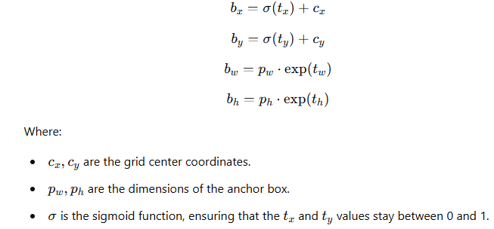
  - Each grid cell is responsible for predicting several bounding boxes (based on anchor boxes) for each scale.

- Objectness Score and Class Prediction
  - For each predicted bounding box, YOLOv11 computes an objectness score to represent the probability that an object exists in the bounding box.
  - This score is computed using a logistic regression model. The system also calculates a class score, representing the likelihood of the object belonging to a specific class.
  - The combined objectness and class prediction scores are used to filter the most relevant bounding boxes.
- Non-Maximum Suppression (NMS)
  - After predicting bounding boxes, YOLOv11 applies Non-Maximum Suppression (NMS) to remove redundant bounding boxes for the same object.
  - NMS evaluates the Intersection over Union (IoU) for pairs of boxes:
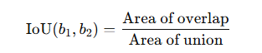

- Loss Function
  - YOLOv11 optimizes multiple loss components to improve detection accuracy:
    - Localization Loss (IoU Loss): Measures the difference between the predicted and ground truth bounding box coordinates.
    - Confidence Loss: Measures the accuracy of the objectness score prediction.
    - Classification Loss: Measures the accuracy of the predicted class label.
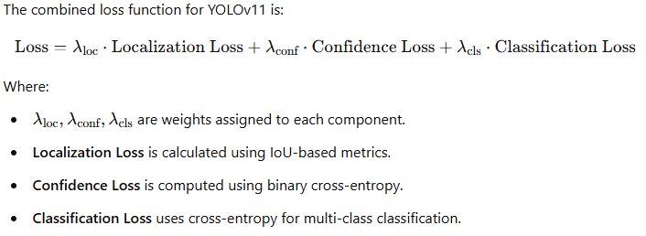

6.4 OUTPUT SCREENS:
HOME PAGE


ABOUT PAGE :
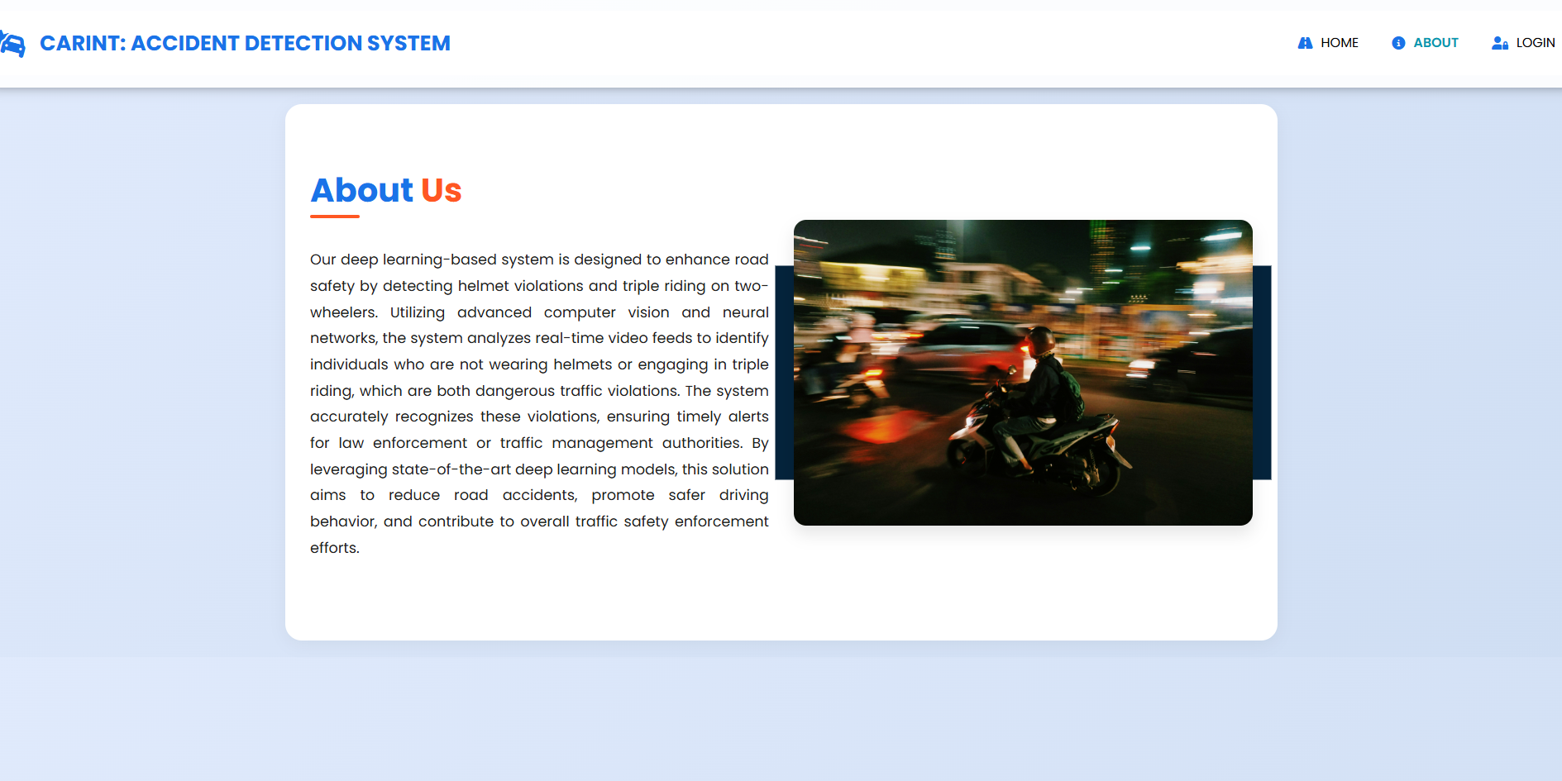

Register Page

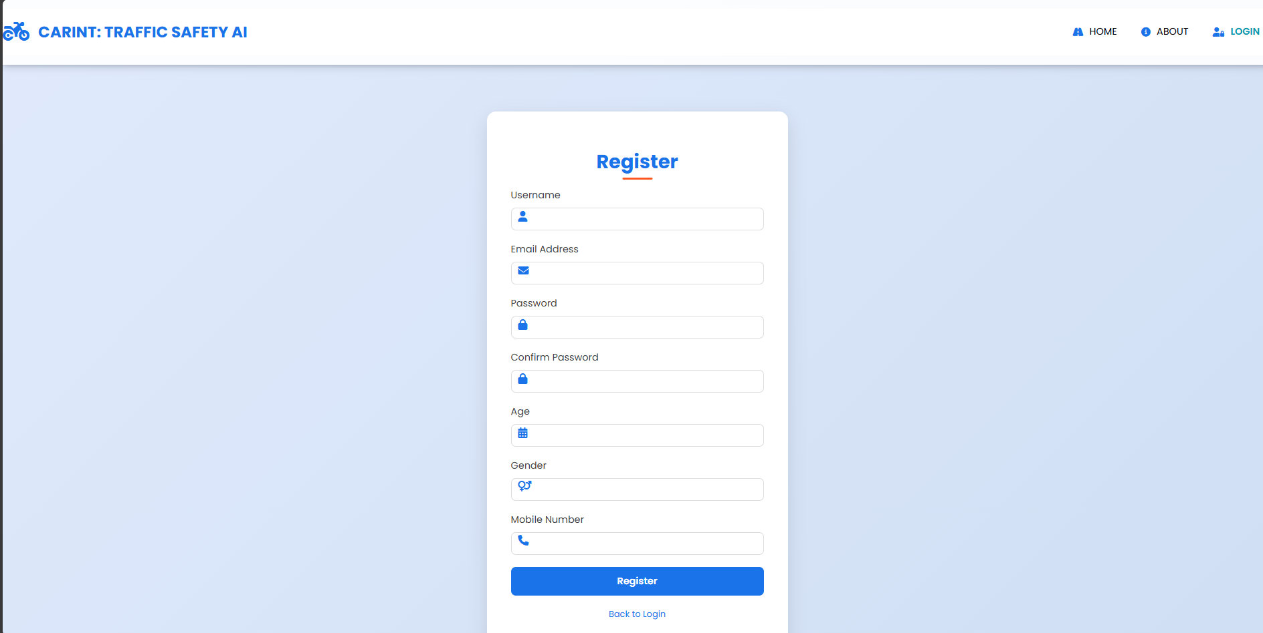
Login page
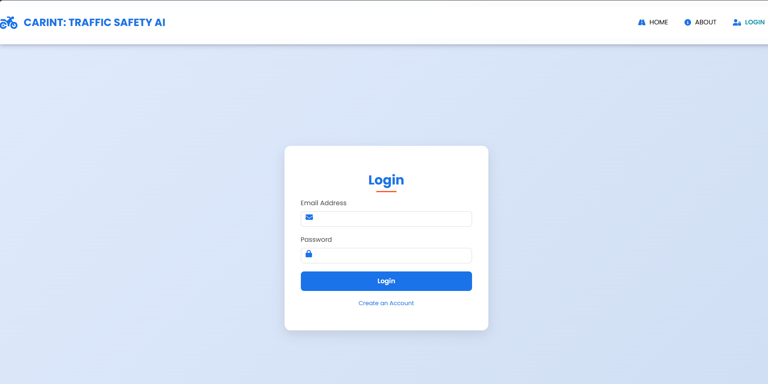

Home Page:


Prediction page
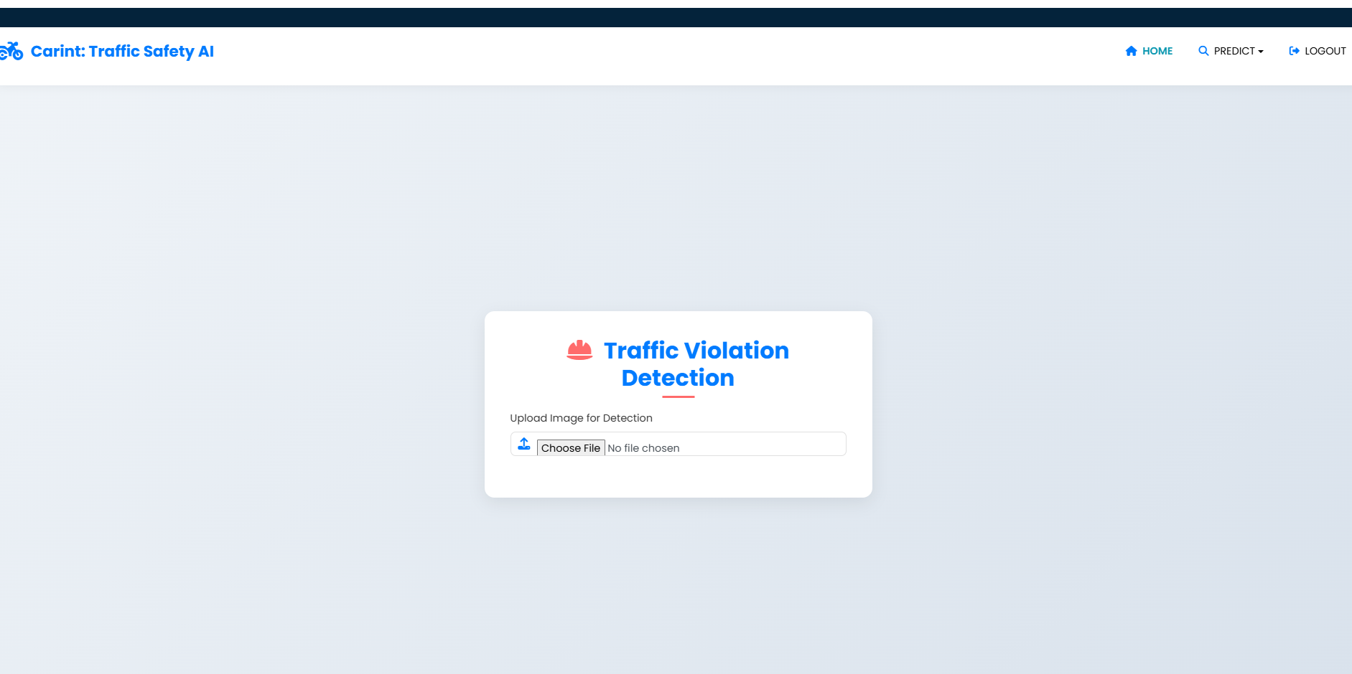

Result Page:
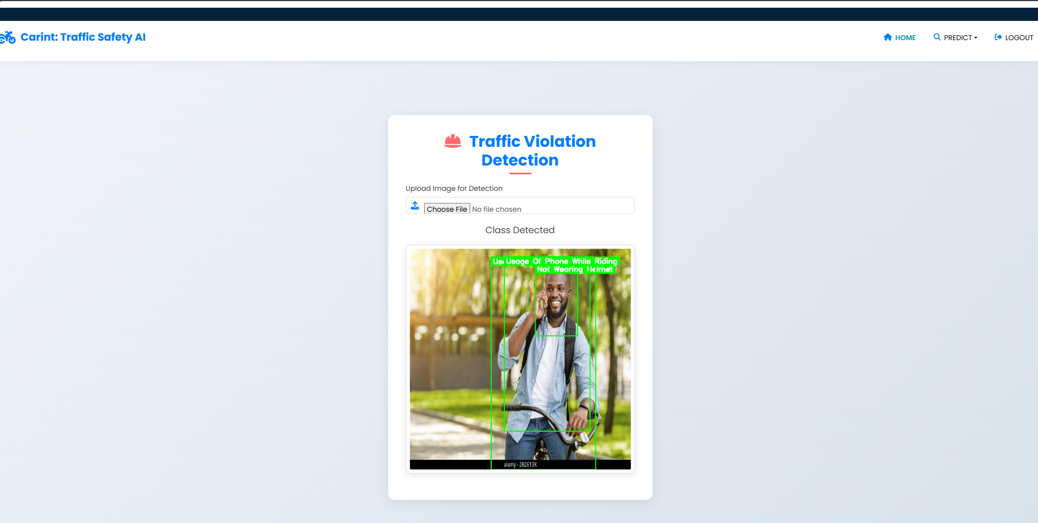

7.SYSTEM STUDY AND TESTING

7.1 System Testing
The purpose of system testing in the traffic violation detection system is to identify defects and ensure that the software meets functional requirements, user expectations, and operates efficiently. Testing verifies that the system functions correctly and can detect violations such as not wearing helmets, triple riding, phone usage while riding, and wheeling in real-time. Various types of testing methods are applied to validate different aspects of the system.

7.2.1 Unit Testing
Unit testing involves validating the functionality of individual components of the traffic violation detection system. This ensures that each module, such as the YOLOv8-based real-time video processing module, the user interface, and the violation visualization dashboard, functions correctly in isolation. Unit tests validate that the system processes video feeds accurately and that the YOLOv8 and YOLOv11 models detect violations such as helmet usage, triple riding, and phone usage with the expected output. Additionally, the system's video input and detection modules are validated to ensure they handle data inputs appropriately.

7.2.2 Integration Testing
Integration testing is conducted to verify that the individual components of the traffic violation detection system work seamlessly together. This includes validating the interaction between the video stream input, YOLOv8 and YOLOv11-based violation detection, and the real-time visualization of results through Streamlit. The goal is to ensure smooth data flow between different modules without errors, and that detected violations are displayed on the user interface correctly.
Test Results: All integrated components successfully communicated, processed video streams, and generated accurate violation classifications without system errors.

7.2.3 Functional Testing
Functional testing evaluates whether the system meets the business and technical requirements for detecting traffic violations. The following functionalities were tested:
- Video feed upload validation: Ensuring correct formats and real-time streaming.
- Real-time violation detection and classification using YOLOv8 and YOLOv11.
- Visualization of results in the interactive front-end interface.
- Report generation and download functionality for violations detected.
Test Results: All functional requirements were met successfully, and the system performed violation detection with high accuracy, classifying helmet violations, triple riding, phone usage, and wheeling in real-time.

7.2.4 White Box Testing
White box testing was conducted to assess the internal logic and ensure the implementation adheres to the expected structure. This testing included:
- Verification of the preprocessing steps for video enhancement, ensuring clear and high-quality frames for YOLOv8 and YOLOv11 to analyze.
- Execution of violation classification using YOLOv8 and YOLOv11 models, confirming their performance in detecting traffic violations.
- Evaluation of backend operations related to storing and retrieving violation data, ensuring accurate logging and storage of detected incidents.

7.2.5 Black Box Testing
Black box testing was performed to evaluate the system's functionality from the user's perspective, focusing on interactions and outputs without knowledge of the internal workings. Test cases included:
- Uploading different video feeds with varying traffic scenarios to test if the system can detect violations such as not wearing a helmet, triple riding, or phone usage.
- Detecting if the system correctly identifies and classifies multiple violations simultaneously.
- Ensuring smooth user experience and intuitive navigation in the front-end interface.
Test Objectives:
- All video input fields should function correctly.
- The system should handle valid and invalid video inputs appropriately.
- All user navigation links and actions should operate as expected.
- The system should provide accurate violation classification results in real-time.
Features Tested:
- Verified that video uploads and streams are handled correctly, with real-time processing.
- Ensured that duplicate violations were not logged.
- Confirmed that violation detection results were displayed with clear bounding boxes and labels on the interface.

Acceptance Testing
User Acceptance Testing (UAT) was conducted to ensure that the system meets the end-user requirements. The system was tested by traffic authorities and law enforcement agencies to validate its usability, accuracy, and efficiency in detecting traffic violations. Feedback from the users was incorporated to improve the system’s reliability and performance for practical deployment in traffic monitoring applications.

This version of the System Testing section is adapted to reflect the detection of traffic violations using YOLOv8 and YOLOv11 and includes specific details about how each type of testing is applied to ensure the system functions correctly.

Test cases:

S.NO | Test Case | Input | Expected Output | Actual Output | Pass/Fail
1 | Helmet Violation Detection | Video feed with a rider not wearing a helmet | Bounding box around the rider's head with a label “Helmet Violation” | Bounding box around the rider with the correct label | Pass
2 | Triple Riding Detection | Video feed showing three riders on a motorcycle | Bounding box around the motorcycle and a label “Triple Riding” | Bounding box around the motorcycle with correct detection for triple riding | Pass
3 | Phone Usage Detection | Video feed with a rider holding a phone | Bounding box around the rider’s hand with a label “Phone Usage” | Bounding box correctly highlighting the hand with a label for phone usage | Pass
4 | Wheeling Detection | Video feed showing a rider performing a wheelie | Bounding box around the motorcycle with a label “Wheeling” | Bounding box correctly detected on the motorcycle with a label for wheeling | Pass
5 | Multiple Violation Detection | Video feed showing a rider not wearing a helmet and using a phone | Bounding box for both violations with labels “Helmet Violation” and “Phone Usage” | Bounding boxes detected correctly for both violations and appropriate labels shown | Pass
6 | Invalid Input Format (Non-video input) | Invalid file format (e.g., .txt or .jpeg) | System should reject the input and display an error message indicating invalid format | Error message indicating incorrect file format | Pass
7 | Image Size Validation | Very large image (e.g., 5000x5000 pixels) | Image should be resized to 640x640 for processing | Image is resized correctly to the appropriate input size without losing integrity | Pass
8 | Real-time Processing Efficiency | Continuous video stream from camera | System processes and displays the detected violations in real-time with minimal delay | Real-time processing with bounding boxes appearing in sync with the video stream | Pass
9 | Non-Maximum Suppression (NMS) | Video feed with multiple overlapping bounding boxes | Only the most confident bounding box should remain for each object | Redundant bounding boxes are correctly suppressed, and only the most confident box remains | Pass
10 | Object Detection Performance | Video feed with varying lighting conditions | System should still detect violations accurately despite changes in lighting | System detects violations accurately, even under varying lighting conditions | Pass
11 | User Interface Functionality | Interaction with the Streamlit UI (e.g., uploading a video) | Smooth interaction, video upload completed, and results displayed in real-time | UI functions as expected, with the video uploaded and results displayed without issues | Pass
12 | Report Generation | Detected violation data | PDF or CSV report generated containing details of the violations (e.g., timestamp, type of violation) | Report is generated with correct violation details and in the specified format | Pass
13 | Detection Accuracy with Overlap | Video feed with overlapping objects (e.g., riders close together) | The system should accurately detect each violation, even when objects overlap | Detected violations correctly, even when riders are close together or overlapping | Pass
14 | Database Storage | Detection results from a video feed | System should store detected violations in the database, including timestamps and violation details | Database logs contain the correct violation data with appropriate metadata | Pass
15 | User Access and Security | User attempts to access unauthorized areas of the system | System should restrict access and show an appropriate error message | Access is restricted, and error message is displayed for unauthorized access attempts | Pass

8. CONCLUSION
The proposed traffic violation detection system using YOLOv8 and YOLOv11 offers a transformative approach to improving road safety and enhancing traffic law enforcement. By utilizing advanced deep learning models, the system efficiently detects violations such as helmet non-compliance, triple riding, phone usage while riding, and wheeling in real-time. The backend, implemented in Python and optimized for processing power, ensures seamless video feed analysis, while the front-end interface, built with Streamlit, provides an intuitive platform for traffic authorities to monitor violations easily. This project addresses the limitations of traditional traffic monitoring systems by offering a scalable, accurate, and real-time solution. The system reduces human error, enhances the efficiency of law enforcement, and provides a reliable tool for ensuring safer roads. By automating the detection of traffic violations, the system promotes timely actions and contributes significantly to road safety.
9. FUTURE ENHANCEMENTS
Future improvements for this system could involve extending its detection capabilities to include additional traffic violations and integrating more advanced deep learning models. Incorporating transfer learning and ensemble techniques could further boost accuracy and robustness across various traffic scenarios. The system can be optimized for more efficient real-time processing, allowing it to handle higher video stream resolutions and larger-scale traffic monitoring applications. Additionally, cloud-based solutions could be implemented to enable remote access, integration with IoT systems for smart traffic monitoring, and collaboration with robotic enforcement systems for automated actions. Future development could also focus on enhancing the predictive capabilities of the system, providing insights into potential violations before they occur. The integration of AI-driven predictive analytics could provide traffic authorities with real-time alerts, further improving overall traffic safety. As the system evolves, it can be expanded to monitor other aspects of traffic safety, including vehicle speed and dangerous driving patterns.

REFERENCES
[1] C. Huang, Q. Liu, and S. Yu, “Regions of interest extraction from color image based on visual saliency,” The Journal of Supercomputing, vol. 58, no. 1, pp. 20–33, 2011.
[2] Chen, X., Ma, H., Wan, J., Li, B., & Xia, T. "Multi-view 3D object detection network for autonomous driving." In Proceedings of the IEEE Conference on Computer Vision and Pattern Recognition (CVPR), pp. 6526–6534, 2017. DOI: https://doi.org/10.1109/CVPR.2017.691.
[3] Chen, H., & Zhang, Z. "Hybrid neural network based on novel audio feature for vehicle type identification." Sci. Rep., vol. 11, pp. 1–10, 2021. DOI: https://doi.org/10.1109/I2MTC43012.2020.9129183.
[4] Feng, T. T., & Ge, H. Y. "Pedestrian detection based on attention mechanism and feature enhancement with SSD." In Proceedings of the International Conference on Communication, Image and Signal Processing (CCISP), pp. 145–148, 2020. DOI: https://doi.org/10.1109/CCISP51026.2020.9273507.
[5] Sarath, S. "Human emotions recognition from thermal images using YOLO algorithm." In Proceedings of the International Conference on Communication and Signal Processing (ICCSP), pp. 1139–1142, 2020. DOI: https://doi.org/10.1109/ICCSP48568.2020.9182148.
[6] Ishak, P., et al. "An efficient real-time colonic polyp detection with YOLO algorithms trained by using negative samples and large datasets." Computers in Biology and Medicine, vol. 105031, 2022. DOI: https://doi.org/10.1016/j.compbiomed.2021.105031.
[7] Yizhou, C., et al. "Generative Adversarial Networks in Medical Image augmentation: A review." Computers in Biology and Medicine, vol. 105382, 2022. DOI: https://doi.org/10.1016/j.compbiomed.2022.105382.
[8] Qiu, G., et al. "Medical image augmentation for lesion detection using a texture-constrained multichannel progressive GAN." Computers in Biology and Medicine, vol. 105444, 2022. DOI: https://doi.org/10.1016/j.compbiomed.2022.105444.
[9] Kyle, M., et al. "A YOLO-based software for automated detection and analysis of rodent behavior in the open field arena." Computers in Biology and Medicine, vol. 104474, 2021. DOI: https://doi.org/10.1016/j.compbiomed.2021.104474.
[10] N. Li, X. Lyu, S. Xu, Y. Wang, Y. Wang, and Y. Gu, “Incorporate online hard example mining and multi-part combination into automatic safety helmet wearing detection,” IEEE Access, vol. 9, no. 1, pp. 139536–139543, 2021.
[11] H. Song, X. Zhang, J. Song, and J. Zhao, “Detection and tracking of safety helmet based on DeepSort and YOLOv5,” Multimedia Tools and Applications, vol. 82, no. 7, pp. 10781–10794, 2022.
[12] M. Sadiq, S. Masood, and O. Pal, “FD-YOLOv5: A fuzzy image enhancement based robust object detection model for safety helmet detection,” International Journal of Fuzzy Systems, vol. 24, no. 5, pp. 2600–2616, 2022.
[13] X. Chen and G. Yang, “Data sensing and processing tensioning system based on the Internet of Things,” Applied Sciences, vol. 9, no. 2, pp. 310–327, 2019.
[14] P. Bonifacci, E. Colombini, M. Marzocchi, V. Tobia, and L. Desideri, “Text-to-speech applications to reduce mind wandering in students with dyslexia,” Journal of Computer Assisted Learning, vol. 38, no. 2, pp. 440–454, 2022.
[15] H. Sne and K. Ajay, “Hyperspectral imaging and target detection algorithms: A review,” Multimedia Tools and Applications, vol. 81, no. 30, pp. 1573–7721, 2022.
[16] A. Hanif, M. Muaz, A. Hasan, and M. Adeel, “Micro-Doppler based target recognition with radars: A review,” IEEE Sensors Journal, vol. 22, no. 4, pp. 2948–2961, 2022.

